|  |  |
| --- | --- |
| EGC_Black | Student Name \_\_\_\_\_\_\_\_\_\_\_\_\_\_\_\_\_\_\_\_\_\_\_    **Eastern Goldfields College**  Mathematics Applications U3&4 2018  Test 5 1– Calculator Free Section |
| **Working Time: 20 minutes** | **Total Marks: 19 marks** |

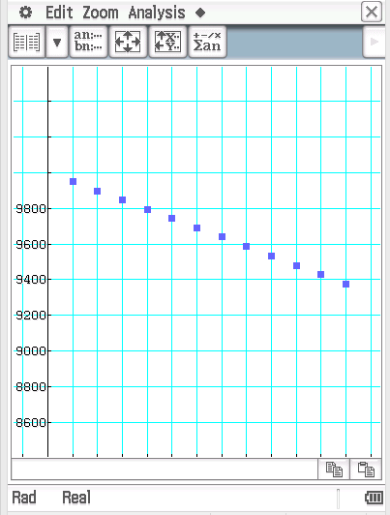**Question 1 [6 marks: 2, 2, 2]**

Nigella has a loan of $10,000 which is at 5.9% p.a. interest compounding monthly. She is making $100 monthly repayments. Nigella is using her calculator to predict the amount she will have owing at the start of each month for the first twelve months. The graph right depicts that.

Consider the graphs at the bottom of the page. Each graph depicts the balancing owing on the loan at the start of each month for the first twelve months of the loan.

1. Which of the graphs depict the effect of increasing the repayment to $300 per month on the balance at the start of each month?
2. Which of the graphs depict the effect of decreasing the interest rate to 3% p.a but keeping the monthly repayments at $100 per month, on the balance at the start of each month?
3. Which of the graphs below depict the effect of decreasing the interest rate to 3% p.a and increasing the monthly repayments to $300 per month, on the balance at the start of each month?

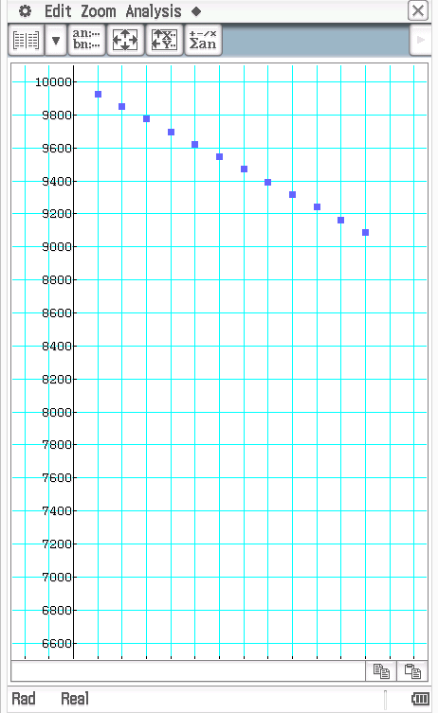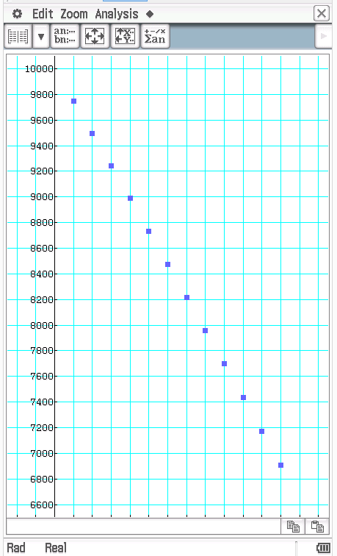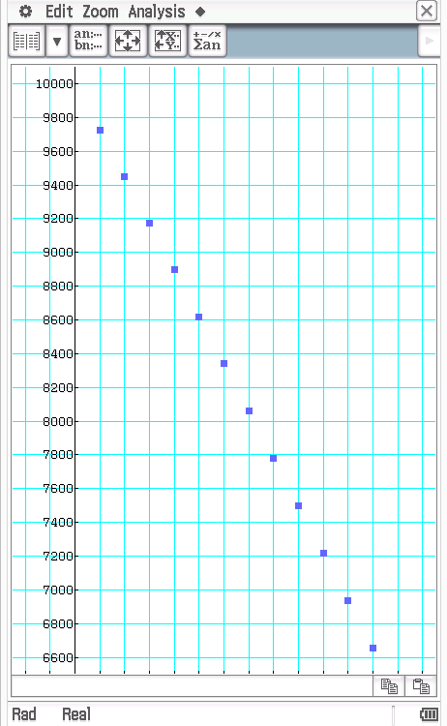Graph A Graph B Graph C

**Question 2 [10 marks: 1, 1, 3, 2, 2, 1]**

John borrows $1000 and repays $200 per month. Each month, interest is added and a repayment is made. The following table shows the amount owed and the repayments. Note that the final repayment is whatever is required to clear what is still owed. That is, it does not need to be $200.

|  |  |  |  |  |
| --- | --- | --- | --- | --- |
| **Month** | **Amount owed at the beginning of month** | **Interest** | **Repayment** | **Amount owed at end of month** |
| 1 | $1000.00 | 1% of $1000.00 = **A** | **B** | $810.00 |
| 2 | $810.00 | 1% of $810.00 = $8.10 |  | $618.10 |
| 3 | $618.10 | 1% of $618.10 = $6.18 |  | $424.28 |
| 4 | $424.28 | 1% of $424.28 = $4.24 |  | $228.52 |
| 5 | $228.52 | 1% of $228.52 = $2.29 |  | $30.81 |
| 6 | $30.81 | 1% of $30.81 = $0.31 |  | Nil |
|  |  | Total Repayments | **C** |  |

1. What is the annual interest rate?
2. Justify why the monthly rate is 1%?
3. Determine the values of A, B and C.
4. What is the total interest paid on this loan?
5. For many loans, interest is compounded daily and payments are made monthly. Would this process have given John a higher or lower amount of interest over the term of his loan? Explain your choice of answer.
6. If John kept his original loan the same except the rate of interest was doubled, would the interest accrued on his loan over its term have been (circle the your answer):
7. Twice as much
8. Less than twice as much
9. More than twice as much

**Question 3 [3 marks]**

The following graphs relate to the recursive rules below. Match each graph to the relevant recursive rule.

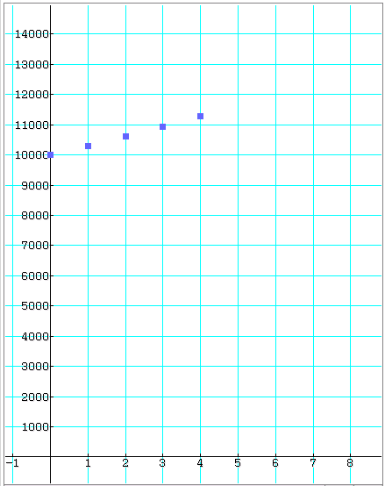 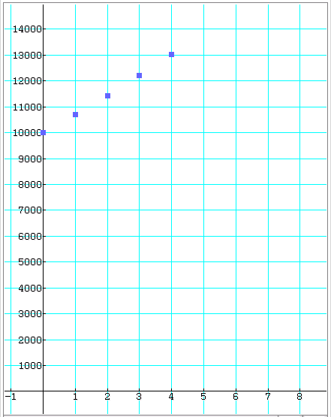

2

1

$$A: T_{n+1}={1.05T}_{n}+200 \\ T_{0}=10 000$$

$${B: T}_{n+1}={1.05T}_{n}-600$$ $T_{0}=10 000$

$$C: T_{n+1}={1.05T}_{n}-500$$

$$T_{0}=10 000$$

$$D: T_{n+1}={1.05T}_{n}-200$$

$T_{0}=10 000$

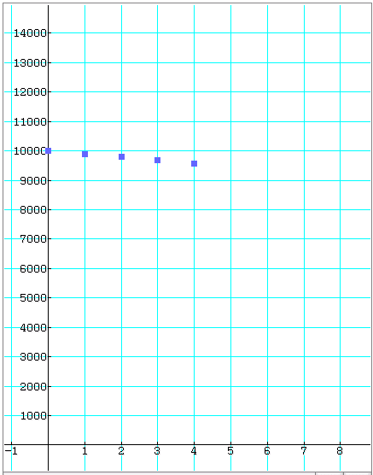 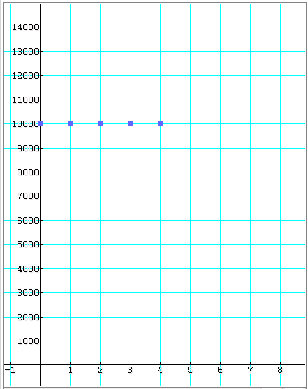

4

3

|  |  |  |  |  |
| --- | --- | --- | --- | --- |
| **Graph** | 1 | 2 | 3 | 4 |
| **Recursive Rule** |  |  |  |  |

|  |  |
| --- | --- |
| EGC_Black | Student Name \_\_\_\_\_\_\_\_\_\_\_\_\_\_\_\_\_\_\_\_\_\_\_    **Eastern Goldfields College**  Mathematics Applications U3&4 2018  Test 5 1– Calculator Assumed Section |
| **Working Time: 33 minutes** | **1 x A4 Notes + Calculator Total Marks: 27 marks** |

**Question 1 [7 marks: 3, 2, 2]**

Once reaching retirement age Betty draws on her superannuation and invests it into an account paying interest 7.3% p.a. compounding annually. She will withdraw $47 000 after one year and after each year thereafter. Betty has $520 000 in her superannuation upon retirement.

1. State the recursion rule for the amount left in the investment at the start of each year.
2. How much is left in the investment account at the start of the 14th year?

Betty retires at age 65 and she wants this investment to continue paying a regular, constant withdrawal each year until she is at least 90 years old.

1. If the investment is to last until she is at least 90 years old, what is the most she can withdrawal each year?

**Question 2 [2 marks]**

What is the effective rate of interest for an investment earning 7% p.a. compounded monthly?

**Question 3 [2 marks]**

The Shire of Perth wants to create a perpetual award for an outstanding young person who gives of themselves to the community. They wish for the award to include an education grant of $900. The investment account’s interest is 7.0% p.a compound annually. How much would they need to invest in the account in order to create this annual perpetual award?

**Question 4 [4 marks]**

Consider the following investment accounts for a $10 000 investment over 10 years.

**Account A:** 7.2% interest p.a compounding annually for the first 3 years and then monthly at a rate of 6% p.a there after.

**Account B**: 5.0% interest p.a compounding monthly.

**Account C**: 4.5% interest p.a compounding daily.

Which account offers the highest return? Justify your answer.

**Question 5 [11 marks: 2, 2, 2, 3, 1, 1]**

Gordon borrows some money and aims to pay it off in 12 months by making regular monthly repayments. The interest rate he is being charged is 9% p.a. compounding monthly.

Consider the following partial table containing details of the loan.

|  |  |  |  |
| --- | --- | --- | --- |
| **Month** | **Balance at the start of the month** | **Interest** | **Balance at the end of the month** |
| 1 |  | 18.75 | 2318.75 |
| 2 | 2318.75 | 17.39 | 2136.14 |
| 3 |  |  |  |
| … |  |  |  |
|  | 34.75 |  | 0 |

1. How much are the monthly repayments
2. How much money did Gordon borrow?

1. What is the balance at the end of the 3rd month?
2. How long does it take Gordon to pay off the loan and calculate the total amount of interest Gordon pays?

Gordon wanted to pay the loan off in 12 months.

1. Calculate how much he would need to pay each month if he is to pay the loan off in 12 months.
2. Besides increasing the repayments, suggest another way Gordon could decrease the time taken to repay the loan.

**END OF TEST**